Post Restructuring Tool

The Post restructuring functionality allows you transfer a group of employees from one part of the structure to another.

 | NB. The Organisational Hierarchy must be modified as shown in sections C and D above before processing the Post Restructuring.

The tool enables employees to be moved within different areas of the structure based on the following scenarios:

- Move an employee to another post
- Move an employee to another area within the structure ‘Move Department’
- Move a Post and linked Employees to another Post
- Move a Post and linked Employees from one area within the Organisation to another area within the organisation
- Move a level within the structure i.e. all posts and linked employees from one area to another e.g. Move all employees in a Department to another Department
- The most common scenario would be to move Organisation Structure to Organisational Structure i.e. Move all employees in a Department to another Department

Personnel>Maintenance>Post Management>Organisational Hierarchy

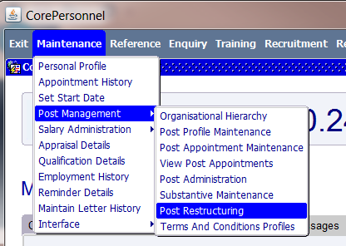

Viewing completed restructures

  - In the Organisation Restructuring Search screen click Search to view the list of profiles that were previously created.

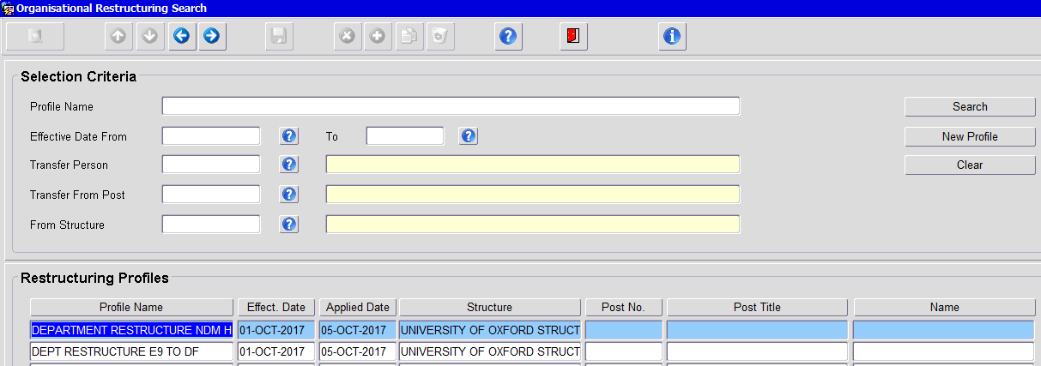

  - Double click on a specific profile to view the details.

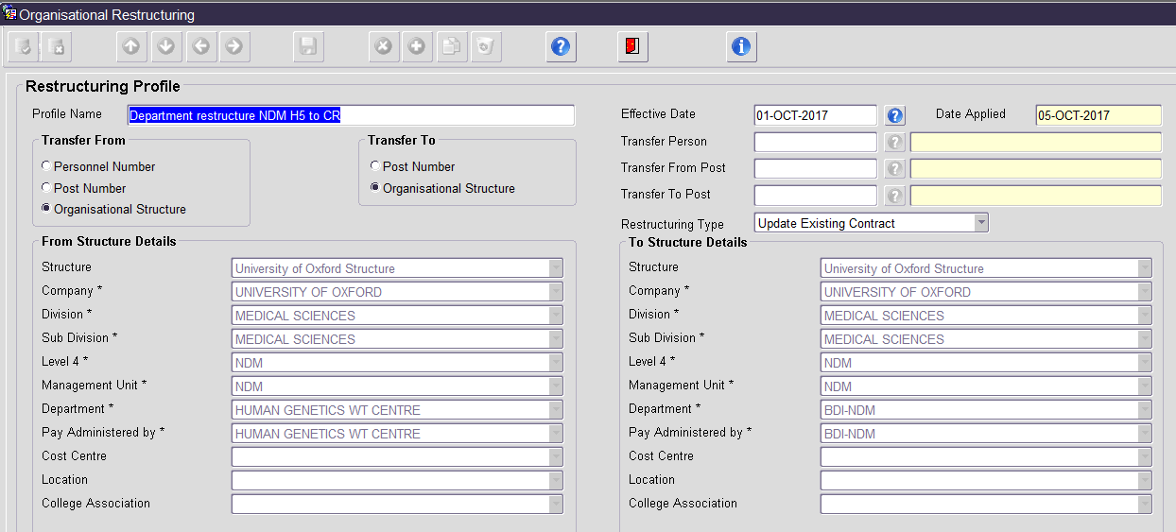

Processing a Restructure

  - To create a New Profile click on ‘New Profile’.

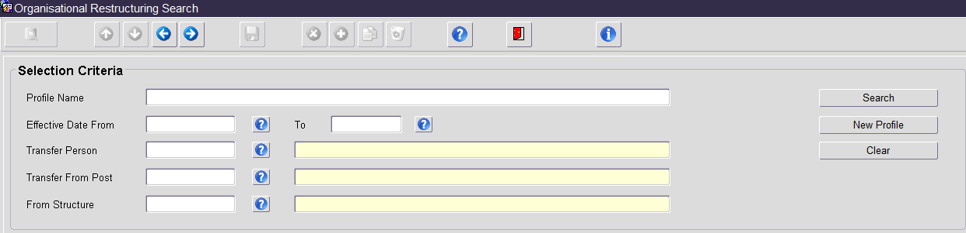

The Organisational Restructuring window opens:

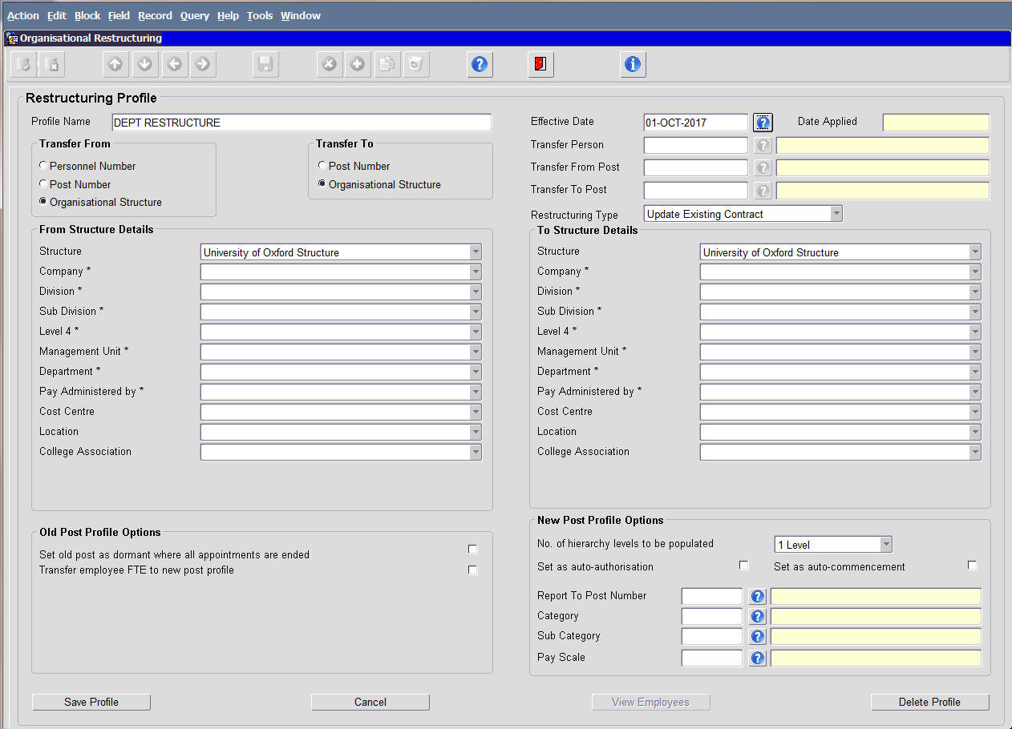

  - Enter/select details as specified below:
Field Name | Details
Profile Name | Enter a suitable name (remember you may wish to search on this in the future)
Effective Date | Enter the relevant date (this will be the date that the new appointments are effective from).
Transfer From | Tick ‘Organisational Structure’
Transfer To | Tick ‘Organisational Structure’
Restructuring Type | Select ‘Update Existing Contract’
From Structure details | Enter/Select the details as shown below
Structure   | University of Oxford.  NB: The remaining fields will not appear until you have selected this.
Company through to Pay Administered by | As per the current hierarchy.
To Structure Details | Enter/Select the details as shown below
Structure   | Select University of Oxford  NB: The remaining fields will not appear until you have selected this.
Company through to Pay administered by | Select the new hierarchy.

 | NB. If applicable you will need to group the records by ‘Pay Administered by’ i.e. Payadmin by DEP and Payadmin by DIV.

  - Click Save Profile. The View Employees button will be activated.

  - Click View Employees to view the list of current active employees and posts matching the details entered in the From Structure Details section.

  - Select the Transfer Reason e.g. Restructuring and click Save.

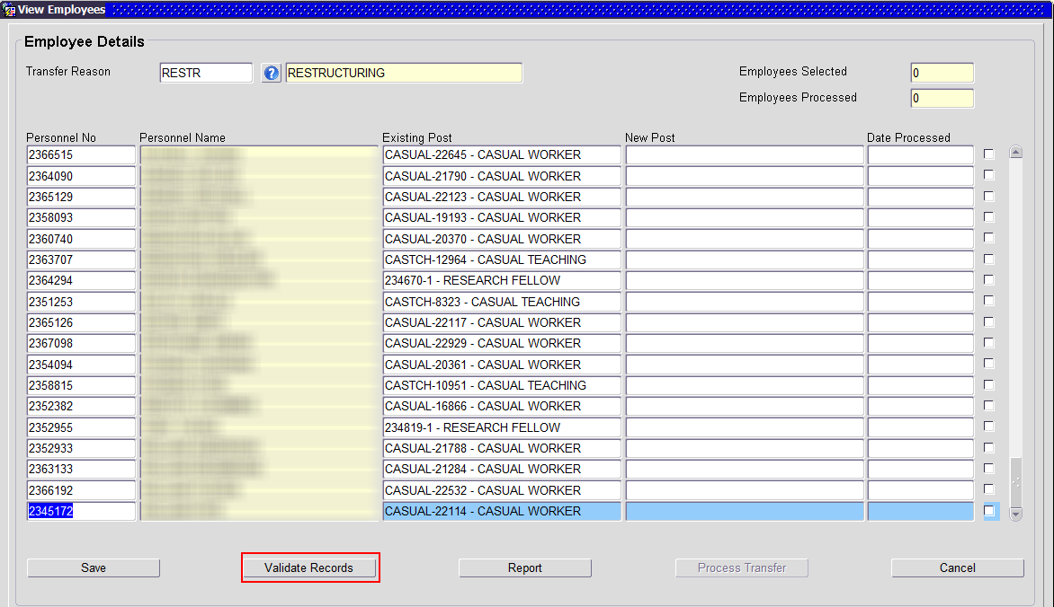

  - Click the Validate Records button which is now active. Invalid records will be highlighted in RED.

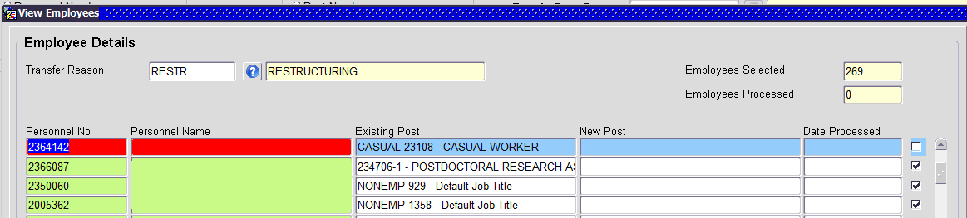

 | NB: All records must be validated before the transfer can be completed.  Only commenced appointments will be included in the Restructuring Process.

  - To view validation errors, double click in the red field for each record. Error examples include “Hierarchy details do not exist” or “Employee has a confirmed future appointment.

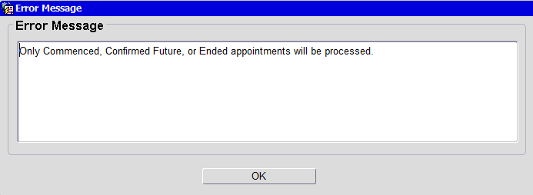

  - CASUAL, CASTCH, NONEMP and AGENCY records are not to be processed via the Restructure Tool and must be unticked. A separate process exists for these records.

  - Click Process Transfer to complete the restructure.

  - Each record processed will be displayed with details of the new Post Number, Post Title and date processed.

